

Coal Lab 13
Tasks
Tasks :1
1. Write an Assembly program to print pattern using nested loops and a procedure
*
**
***
****
*****

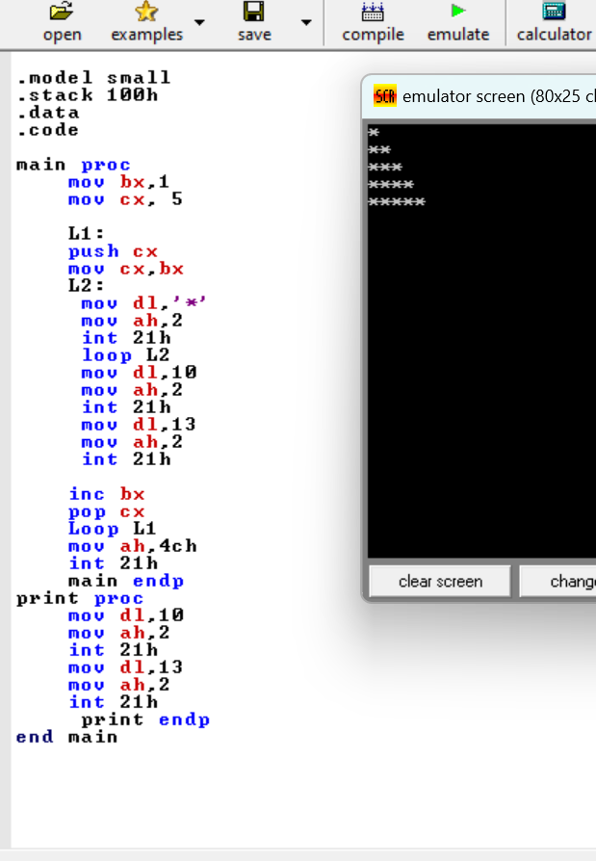

Tasks :2
2. Write an Assembly program to print your name and sap id use both a procedure and macro
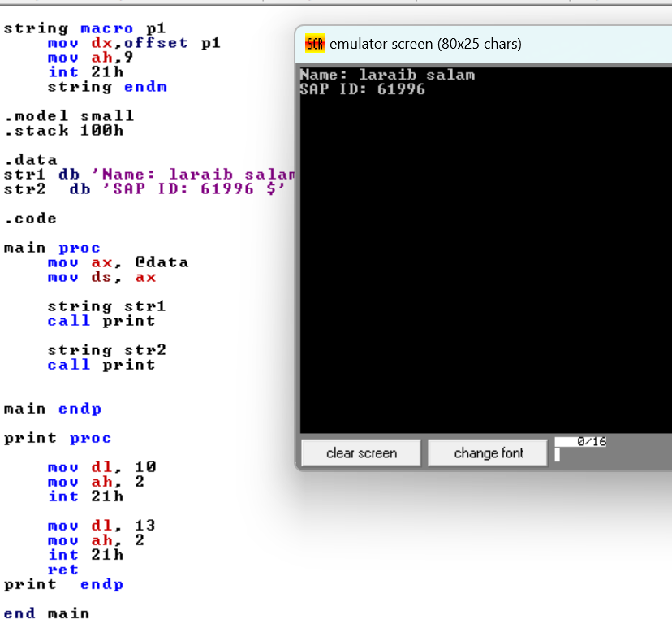

Tasks :3
3. Write an Assembly program to print 5 strings with a procedure.
